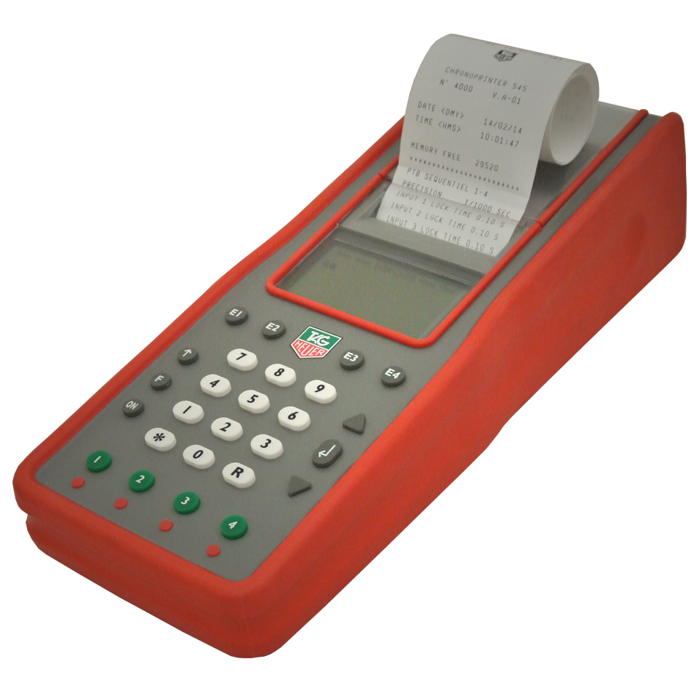
CP-545 FIRMWARE UPDATE
GO ONTO TAG WEBSITE TO FOLLOWING PAGE

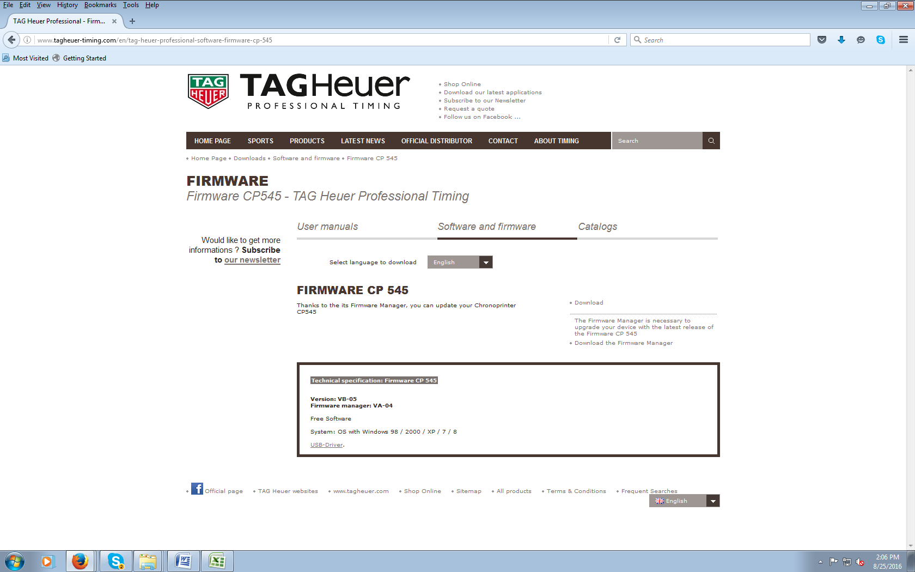

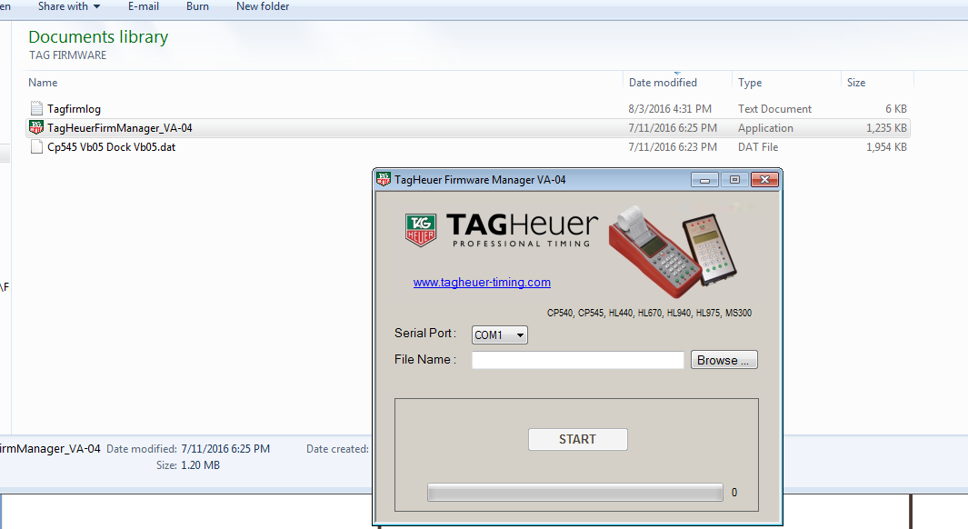

- DOWNLOAD NEW FIRMWARE AND PLACE IT IN AN EASY TO FIND FOLDER
- SELECT COM PORT (COM 5)
- BROWSE TO WHERE THE NEW FIRMWARE IS (.DAT FILE)
- PRESS START
- FOLLOW DIRECTIONS

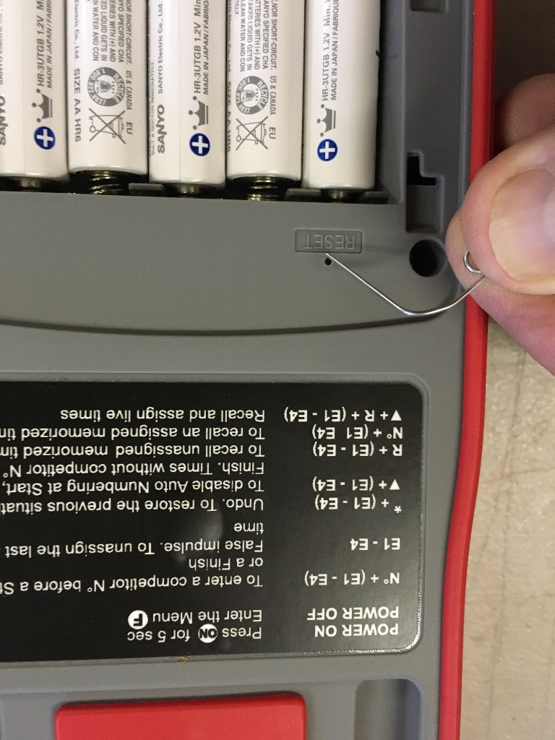

Use paper clip to reset if needed. Sometimes this will be needed after firmware update, but not always.

SUPPORT

- THE Phoenix Sports Technology discussion forum is a great place to start:
- http://www.timingguys.com/6/ubb.x OR www.timingguys.com
- Fred Patton can be reached on his worldwide cell phone at 610-972-5385
- The TAG HEUER factory site has a great deal of information as well. You can download the latest manuals and brochures.

- www.tagheuer-timing.com

